APWG ECrime eXchange User Guide

Version 2.0, X July 2021
Table of Contents

Overview: Get to Know the eCrime eXchange

This user guide tells you how to use the APWG’s eCrime eXchange (the “eCX”). Here you can learn what kinds of data it contains, and tips for how to get the most out of it.

Online API Documentation

This user guide does not attempt to detail all the workings of the eCX’s API. To learn more details about the API, please examine the online API documentation. To view that, log in at https://ecrimex.net and visit the “API” section. The API section also contains your API key. There is also additional documentation provided within each module, which details what fields you may submit and manipulate, what fields are mandatory versus optional, allowed values, and so on.

[NOTE material on GITHUB]

Your Account, and Your Organization’s Account

Log into the eCX’s web interface at https://ecrimex.net. There you can view and update your user information, including your password, contact info, and mail and group preferences.

Each user of the eCX receives their own account, with its own username and password. Each user account is associated with an APWG organization membership. An APWG member organization can have multiple individual users.

If your organization needs to create a new user account for one of your staff members, an existing user should send a request to support@ecrimex.net . Please include the new user’s name and email address. New users must have an email address on your organization’s domain name. If an individual leaves your organization, please let us know so that we can suspend their account.

Billing contacts: each APWG member organization has a billing contact on file with the APWG. APWG sends annual membership invoices to the billing contact. We ask that you keep your billing contact up to date. Note that if your organization does not pay its membership fees, the APWG may eventually suspend access to the eCX. We always send reminders before suspending access.

Technical and Business Support

If you need help, please contact our support team at: support@ecrimex.net We’re here to help!

If you’re reporting a suspected outage or a potential bug, please write to us with the details, including a step-by-step account of how you encountered the problem , the error message your received, the time of the problem, and a screenshot if relevant. These will help us diagnose and reproduce the problem for you.

In general, the staff cannot provide detailed evaluations of or fixes to your client-side API code.

The eCX support team occasionally schedules maintenance periods in order to upgrade and service the eCX. When we do so, we will send you advance notice, to minimize disruptions to your work. If there is an unscheduled maintenance, we will send outage notices and updates until the situation is resolved.

Ways to Interact with the Data: UI and API

There are two methods to submit data into the eCX. The eCX has a user-friendly web-based user interface (UI) at https://ecrimex.net. This option works well for low-volume, manual data entry. It’s also handy for browsing data. By default you are allowed to view and submit records through the eCX UI the moment you are approved to access the eCX.
If you want to automate your interaction with the data, use the eCX API. It’s ideal for posting for pulling data in a programmatic way, and can also be used to make queries.
We do not allow users to submit data into the eCX production environment via the API until your automated scripts are proven on the eCX sandbox and then approved for automated submissions – more on this below in the API section that follows.
Both the eCX UI and the eCX API allow you to make changes to existing data.

Data Origin and Quality
The eCX is a user-supported and user-maintained repository of threat data. The data is submitted by vetted APWG members, who are expected to provide reliable data. The data is there for other members to use as-is, per the eCX terms of use. Neither the APWG nor the data submittors guarantee that the data is fit for a given purpose, and the APWG does not guarantee that the data is 100% accurate. This means that the repository may occasionally contain false-positives and outdated information.
Also keep in mind that once an entry has been submitted, the submittor will likely not update the data over time. For example, a phishing URL may have been active at the time it was submitted to the eCX, but the phishing page may not be active at the time you download the data about it. For these reasons, we do not recommend that you use the eCX as an authoritative source of information about whether a malicious event is active (up) or inactive (down). Instead, we hope users will take the data and confirm the activity, if that is important to you.
Most of the modules allow users to submit and manipulate a Confidence Level score. This is a way for users to in, and a useful indicator to other users.
The APWG staff typically do not make changes to existing data in the repository, for several reasons. The APWG vets all members prior to allowing access to the platform, so our user base is 100% full of known good actors. We don't monitor or vet the incoming data. When data needs to be updated we provide our users with the tools to make updates, so members have the same control over the data. And finally, we're a very small team--we don't have the bandwidth for constant moderation of the data, and if we were to be making unilateral changes to the data then we'd be taking the chance of stepping on the toes of our valuable member. If the APWG staff is asked to update data, we will usually forward the request to the member who created the entry with a request to examine and update it as needed.

Confidence Level

[text to come]
There are 4 possible values for confidence, 100 indicates that this phish has been visually confirmed by a staff member. 90 indicates that the phish was found using a ML process. 50 indicates that you or your ML process believes this to be phish, but the phish has not been confirmed by a process that would drive it to a 90 or 100 value, yet you still think the URL should be sent to the eCX phish data repository.

The Modules:

[here I will briefly describe each module and what it contains. ]
- Phish
- Malicious IP. You must sign a special doc to get access.
- Malicious Domain
- Cryptocurrency
- Report Phishing

The first four modules are similar in concept. Some modules have data fields that are unique to them.

The Report Phishing module

- You can send full original phishing emails that you want to add to the ReportPhishing data repository by forwarding them from your inbox to the eCX at reportphishing@apwg.org. From there the eCX parsing logic will pick up the emails and add them into the data repository immediately. This is NOT an email address to forward lists of phish to, as they will not be parsed and picked up – that is the job of the eCX API or the eCX UI. The only approved way to submit phish data to eCX is via either the eCX UI at https://ecrimex.net, or by using the eCX API.

What’s Your Use Case?

The Phishing Module
https://ecrimex.net/go/phish

To submit phish to the eCX there are four values you'll need:
date discovered: This field is a numeric epoch date (number of seconds since Jan 1 1970), the value already entered for you is a conversion of the current time/now into an epoch value. If you'd like to report your phish with an earlier datetime stamp we'd suggest using http://www.epochconverter.com and then use the wizards on the page to work out the correct epoch value for your datetime, and then copy/paste the value into the eCX Add window. Note that there are constraints in place that disallow datetime values in the future, or older than 1 year.
confidence level: There are four possible values for confidence, 100 indicates that this phish has been visually confirmed by a staff member. 90 indicates that the phish was found using a ML process. 50 indicates that you or your ML process believes this to be phish, but the phish has not been confirmed by a process that would drive it to a 90 or 100 value, yet you still think the URL should be sent to the eCX phish data repository.
brand: This indicates the company or entity that the phish is targeting. If you are unsure of the target, you can use “other”. If there are multiple brands targetd on the phishing page, you can use “multiple”, r you can specify the most prominent or relevant brans specifically.

url: The full phishing URL that you want to report

As noted before, all modules and workgroups within eCX follow this same general submission flow, changed by differences in the schema of the data.

Using The eCX API
https://api.ecrimex.net/phish and https://api.sandbox.ecrimex.net/phish

The following is an in-depth overview of usage of the eCX API. If you have any questions about issues within this document please contact us at support@ecrimex.net.

The eCX API is a REST API. If you are familiar with REST API technology then what follows is straight forward. If you have not used a REST API before f- it is well proven technology that has been in use for years, and is not complicated. There is lots of knowledge found via Google searches, but explaining REST is beyond the scope of this document.
The eCX API supports 3 basic REST operations – GET, POST, and PATCH.

  - GET is a data fetch operation that allows for querying of data, and eCX supports multiple parameter options.
  - POST sends new data to eCX within a JSON payload
  - PATCH is used to update existing eCX data values

In every GET, POST, or PATCH operation the eCX API returns data in JSON. There is a GET parameter that will tell the eCX API to return data to you in CSV, however you’ll receive a much smaller subset of data per entity that you will with JSON. This is because using JSON allows us to nest arrays and objects into the JSON schema, and these arrays and objects cannot be represented in CSV, and the data within these JSON objects and arrays are omitted in CSV. Sending data to eCX using POST requires the data payload to be in JSON, CSV is not an option for POST.

FINAL APPROVAL FOR SUBMITTING THROUGH THE eCX UI
No final approval is necessary to submit phish data through the eCX UI, when your user account is approved by the eCX administrators the system automatically gives you access into the phish module and enables you to submit phishing data via the UI.

eCX API TOKEN KEYS

For every eCX API operation your eCX API Key will need to be sent in the request header within the Authorization key/value pair. You’ll see this in the examples for every operation shown here. Your eCX API Key is shown in eCX within your user profile, located at https://ecrimex.net/users/update The eCX API Key is tied to your user account, and allows eCX to determine what access rights you have available.

RESULT CODES

Following standardized API interaction protocols, the eCX API returns result codes indicating success or failure of each operation. Users should always be checking for the expected result code from the operation, and handling situations where the result code returned indicates that the operation failed. The eCX API reports back result codes for malformed queries, missing API token keys, and problems found in other operational states. All of this information on both eCX API use and possible response codes are outlined in the eCX API documentation located at https://ecrimex.net/api .

eCX API DOCUMENTATION
The eCX API documentation is generated using the OpenAPI (formerly Swagger) format. There is even an eCX API documentation option that will dump out the API docs in OpenAPI format. There are many tools for OpenAPI documents online and in GitHub that might help you fast track your API interaction.
On the eCX API documentation page in the eCX UI (https://ecrimex.net/api) you can also find ready-to- go eCX API clients in various languages such as Java, Go, PERL, etc., that were generated using OpenAPI tools to help you fast track your eCX API integration into your business processes.

POSTMAN

Within the eCX Engineering department, the staff uses the free Postman API client to interact manually with the eCX API to perform quick testing and querying for data. The client can be downloaded at https://www.getpostman.com/apps . The various examples that follow were generated from Postman’s option to create the API interaction you are performing in their interface into various programming languages. Information on this Postman feature is outlined in the POST section.

FINAL APPROVAL FOR SUBMITTING THROUGH THE eCX API

The process for beginning to POST data to the eCX API on production first begins with developing your scripts to work off of our sandbox server, located at https://api.sandbox.ecrimex.net . The data you POST or PATCH will never be distributed, so you are welcome to go crazy and work any sort of edge use cases you can envision with any sort of test data.
We recommend setting the eCX API server URL value as a script parameter so you’ll be able to make a quick change later to point to the production server.
The data on the sandbox is reset nightly at 00:00 GMT, and we reseed it with live data pulled from the production server to give you some real and current data to run your scripts against.
We capture usage and performance metrics from all of the servers on the eCX platform. Email support@ecrimex.net when you feel that your submission scripts are well developed. We’ll begin to check the sandbox metrics, and if we see a problem we’ll ask you to make some enhancements, and then reapply once you’ve had 48 hours or so of processing with the new logic and things are looking better. If everything looks fine then we’ll approve you to submit to production. We’ll have you repeat the submit/review process as necessary until your script is well behaved. But this approval step is necessary prior to allowing you to begin submitting data to eCX production.

The Phishing Module

Note that the Phishing Module contains only unique URLs. If a user attempts to POST a URL that is already in the eCX, that POST attempt with be rejected, with a 409 result code (see below). The eCX rejects duplicate URLs in order to keep the data in the repository more usable, and the earliest report of a given URL is also the most useful.

Phishing Module: POST
To POST new data to the eCX API the following pseudo logic should be followed:

POST your phish submission to /phish eCX Check the result code:
IF the result code is 201 THEN the operation was a success
IF the result code is 404 THEN your API token key was missing or invalid
IF the result code is 403 THEN your account permissions prevent you from submitting data
IF the result code is 400 THEN the JSON data did not validate correctly
IF the result code is 428 THEN you attempted to POST a phish as a false positive
IF the result code is 409 THEN this phish has already been entered; use PATCH if you have changes
IF the result code is 412 THEN you attempted to POST a phish with a known good domain on our domains whitelist

The phish data for a POST operation goes in the request body as a JSON object:

{
"url": "http://www.dave.com/test1", "brand": "dave",
"date_discovered": 1517439667,
"confidence_level": 50
}

All 4 key value pairs are required. A 400 error will be returned if anything is missing or malformed.

In the request header set the Content Type as ‘application/json’ to tell the server that the payload it will be dealing with is JSON.

Upon a successful submission the eCX API will return back a response body that contains the data we stored for the submission along with the ID of the phish entity. If you do not care about the return payload and just want to check the result code of the operation for success/fail then you can use the ‘container=empty’ parameter to suppress the response body and save some internet bandwidth.

We’re a PHP shop, so the coding examples that follow will be in PHP, but the logic should be easy enough to translate into another programming language.

POST a phish
No
API token
included and
valid?

/phish POST
Yes
404

User rights to
submit?

No
403

Yes
428
400
No
Data
validates?
Yes
Yes
CF=0?
No
Duplicate URL?
No

Yes Is domain known
good?
Yes
409
Do I have updated
values?
Yes
Run PATCH instead
No
NOTHING TO DO

412

No

data POSTed
to /phish
201

POST using PHP using cURL Example

<?php
$curl = curl_init(); curl_setopt_array($curl, array(
CURLOPT_URL => "https://api.sandbox.ecrimex.net/phish", CURLOPT_RETURNTRANSFER => true, CURLOPT_ENCODING => "",
CURLOPT_MAXREDIRS => 10,
CURLOPT_TIMEOUT => 30,
CURLOPT_HTTP_VERSION => CURL_HTTP_VERSION_1_1, CURLOPT_CUSTOMREQUEST => "POST",
CURLOPT_POSTFIELDS => "{\r\n \"url\": \"http://www.dave.com/test1\",\r\n \"brand\": \"dave\",\r\n
\"date_discovered\": 1517439667,\r\n \"confidence_level\": 100\r\n}", CURLOPT_HTTPHEADER => array(
"Authorization: <your eCX API Token Key goes here>", "Content-Type: application/json"
),
));

$response = curl_exec($curl);
$err = curl_error($curl); curl_close($curl);
if ($err) {
echo "cURL Error #:" . $err;
} else {
echo $response;
}

POST using cURL CLI Example

curl -X POST \ https://api.sandbox.ecrimex.net/phish \
-H 'Authorization: <your eCX API Token Key goes here>' \
-H 'Content-Type: application/json' \
-d '{
"url": "http://www.dave.com/test1", "brand": "dave",
"date_discovered": 1517439667,
"confidence_level": 100
}'

POST using Postman Example
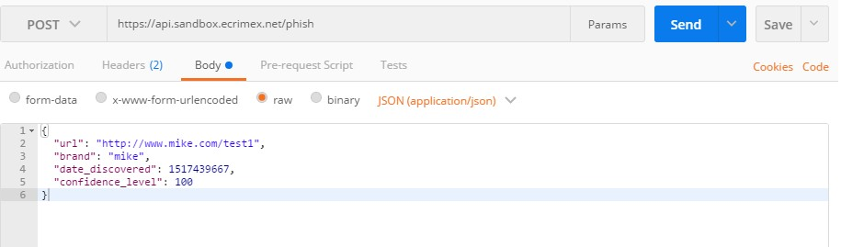

Press the blue Send button to run the POST operation in Postman.

We used the “Code” link that is under and to the right of the blue Send button to export the API operation into the PHP and cURL code you see above. A screenshot of the Code Generation within Postman is below, with the “Code” link circled in orange. You can see the wide range of programming languages Postman will generate code for your query in:

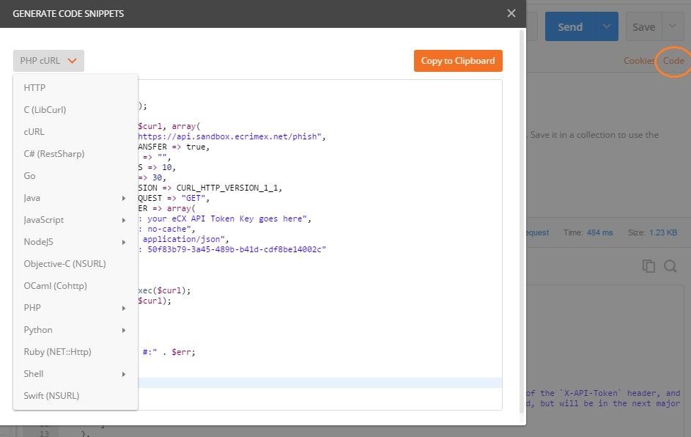

Phishing Module: PATCH

/phish PATCH

No
PATCH a phish
API token
included and
valid?
404

Yes

User rights to
submit?

No
403

Yes

Data
validates?

No
400

Yes
ID is found?

No
404

Yes

Phish is active?

No
400

Yes
409

Write /phish
changes
No
Data includes
changes?
Yes
200

A PATCH requires the ID of the entity that you want to update when you find that you have new data for a specific phish within eCX.
You are able to update data via PATCH for brands, confidence_level, and status. In order to PATCH a phish entity the status must be active, and in order to change a status to active you must include a date_discovered value in the PATCH. You cannot PATCH a URL value, once POSTed to eCX the URL value is immutable.
Set the Content-Type header key to ‘application/json’ to tell eCX that you are sending JSON data with the request.
When we POSTed the example above eCX returned an ID of 87104669 for the new entity that was created. We’ll need this ID for the PATCH operation. You may update any or all of the modifiable fields using a PATCH, in our example we’ll update the brand field, looking for a 200 result code being returned to indicate

PATCH using PHP using cURL Example

<?php
$curl = curl_init(); curl_setopt_array($curl, array(
CURLOPT_URL => "https://api.sandbox.ecrimex.net/phish/87104669", CURLOPT_RETURNTRANSFER => true,
CURLOPT_ENCODING => "", CURLOPT_MAXREDIRS => 10,
CURLOPT_TIMEOUT => 30,
CURLOPT_HTTP_VERSION => CURL_HTTP_VERSION_1_1, CURLOPT_CUSTOMREQUEST => "PATCH",
CURLOPT_POSTFIELDS => "{\r\n \"brand\": \"Daves Brand\"\r\n}", CURLOPT_HTTPHEADER => array(
"Authorization: <your eCX API Token Key goes here>", "Content-Type: application/json"
),
));

$response = curl_exec($curl);
$err = curl_error($curl); curl_close($curl);
if ($err) {
echo "cURL Error #:" . $err;
} else {
echo $response;
}

PATCH using cURL CLI Example

curl -X PATCH \ https://api.sandbox.ecrimex.net/phish/87104669 \
-H 'Authorization: <your eCX API Token Key goes here>' \
-H 'Content-Type: application/json' \
-d '{
"brand": "Daves Brand"
}'

PATCH using Postman Example

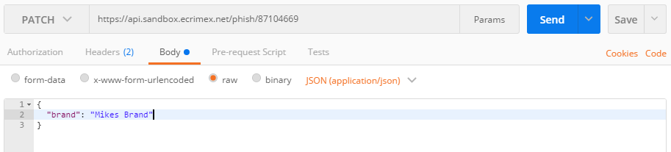

Phishing Module: GET
GET queries the eCX API for data. You can query for a complete result set, or for as little as one record. url_exact is one of many GET query parameters, but the only one we’ll use in this GET example, the documentation for all the parameters is available to help you focus in quickly on the data you really want.

GET using PHP cURL Example

<?php
$curl = curl_init(); curl_setopt_array($curl, array(
CURLOPT_URL => "https://api.sandbox.ecrimex.net/phish?url_exact=https://refunssd- authorised.getrefundnikestore.com/signin/",
CURLOPT_RETURNTRANSFER => true, CURLOPT_ENCODING => "", CURLOPT_MAXREDIRS => 10,
CURLOPT_TIMEOUT => 30,
CURLOPT_HTTP_VERSION => CURL_HTTP_VERSION_1_1, CURLOPT_CUSTOMREQUEST => "GET", CURLOPT_HTTPHEADER => array(
"Authorization: <your eCX API Token Key goes here>"
),
));

$response = curl_exec($curl);
$err = curl_error($curl);
$http_status = curl_getinfo($http, CURLINFO_HTTP_CODE); curl_close($curl);
if ($err) {
echo "cURL Error #:" . $err;
} else {
echo $response;
}

GET using cURL CLI Example
curl -X GET \
'https://api.sandbox.ecrimex.net/phish?url_exact=https://refunssd-authorised.getrefundnikestore.com/signin/' \
-H 'Authorization: <your eCX API Token Key goes here>\

GET using Postman Example
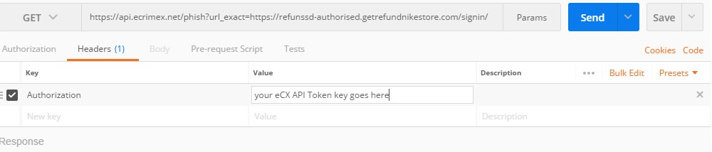

RESULT CODES
Every eCX API operation returns a result code to you.

Checking the result codes being returned to you is critical to understanding the success or failure of the requested operation.
We frown upon users who just throw data at the eCX API without checking for the result code, instead of handling the error and resubmitting when possible. These use cases jump out at us when we review the reporting metrics. Make sure your submitted data returns 201 for POST and a 200 for PATCH, and handle any exceptions that arise.
Here are some examples of a few CLI utilities using parameters that return the eCX API result codes to you.
curl -w "\ncode: %{http_code}\n\n" --request GET --url https://api. sandbox.ecrimex.net/phish/87104669-- header 'Authorization: your eCX API Token Key goes here'
wget --quiet --method GET --header 'Authorization: your eCX API Token Key goes here' --output-document - https://api.sandbox.ecrimex.net/phish/87104669--server-response
http GET https://api. sandbox.ecrimex.net/phish/87104669Authorization:your eCX API Token Key goes here
(http returns a result code by default ^, no special parameter necessary)

ERRORS
eCX API result codes in the 4xx range indicate an error. All of the possible result codes specific to each eCX API operation are documented in the eCX API documentation located at https://ecrimex.net/api

A 404 result code indicates that you’ve either made a mistake in the eCX API URL, or you’ve omitted sending an eCX API key, or the eCX API key you’ve used is invalid.
Outside of a 404 result code, any other 4xx result code will return a response body that contains a JSON error object designed to help you understand what went wrong with your operation.
"error": {
"title": "invalid request", "httpStatus": 400, "messages": [
"'date_discovered' is not allowed to be changed outside of a 'status' change"
]
}

You can see that eCX returns the result code within the JSON error object, as well as a more descriptive error message in a JSON array.
In the case of multiple errors eCX will return multiple message descriptions within the messages array.
"error": {
"title": "invalid request", "httpStatus": 400, "messages": [
"'bad_key' is not a valid body key", "`confidence_level` must be one of 0, 50, 90, 100"
]
}

CryptoCurrency Module

[Note in this section:
- Price field is numeric. Please add prices in crypto. If you want to add values in US$ or Euros or whatever, do that in a NOTE.
- Crime Category has these allowed values:
- Crypto allows users to submit entries containing the same address, unlike how the Phishing module only allows user to submit a given URL once. This is because an address can be used over time to receive or send many tracstions, with different prices etc.]

